
Kara Wuchner Flute Studio
www.karawuchner.com
(714) 227-5581
Winter News
Upcoming Events and Dates to Remember:

December 7th – Capriccio Flute Choir rehearsal, 9:00am – 11:00 am, Master Musician

December 10th – Capriccio Flute Choir performs prelude music for the Temecula City Council Meeting, 6:30-7:30 approximately.

December 23rd–January 3rd: No lessons, Merry Christmas!

January 25th: MTAC Student Musicales, Temecula Library. I would like all Certificate of Merit participants to perform one of their solos at this recital. Everyone else is welcome to perform too! $5 participation fee, plus accompaniment fee, if needed.

February 15th - Capriccio Flute Choir rehearsal, 9:00am-10:30am, Master Musician

February 22nd – Certificate of Merit (individual times not yet determined), Miyamoto School of Music, Temecula

♪Notable Student♪
Chloe Degaris!
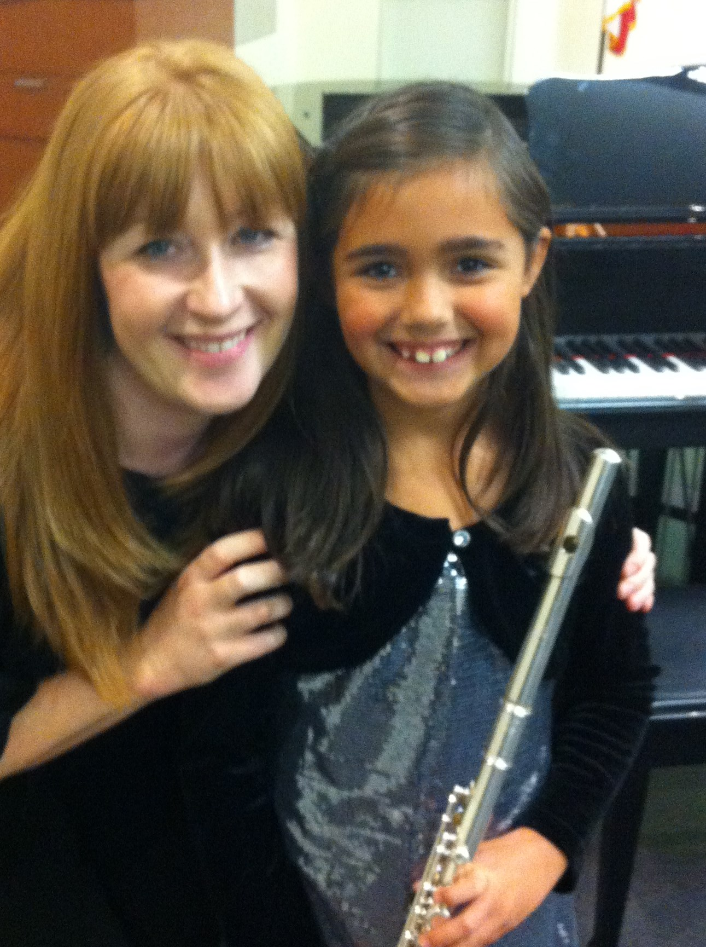
.

She has impressed me with her enthusiasm, dedication, and tremendous improvement over the last few months as she prepares for her first Certificate of Merit. Keep up the good work, Chloe!

Welcome new students:

Skye McAfee
Abigail Mota

Members of Capriccio Flute Choir, performing at
Calvary Baptist Fall Recital


