
Kara Wuchner Flute Studio
www.karawuchner.com
(714) 227-5581
Spring News
Upcoming Events and Dates to Remember:

March 15th: Capriccio Flute Choir rehearsal, 9:00am – 10:30 am, Master Musician

March 30th: San Diego Flute Guild Spring Festival, San Diego State University. A day of all things flute: exhibits, clinics, recitals, and a master class with Robert Dick, Woodwind Faculty at NYU. And, I will be leading the Flute Choir Reading Session from 11-11:45! Contact me for more info or if you’d like to carpool.

March 31st-April 5th: Spring Break
No lessons will be given.

April 12th: Capriccio Flute Choir rehearsal, 9:00am – 10:30 am, Master Musician

May 10th: Capriccio Flute Choir rehearsal, 9:00am – 10:30 am, Master Musician

May 17th: MTAC Musicales
Temecula Library

June 14th: Capriccio Flute Choir rehearsal, 9:00am – 10:30 am, Master Musician

June 21st: Studio Recital, 2pm
Grace Mellman Library

June 23rd-July 5th: Summer Break
No lessons will be given.

.
♪Notable Student♪
Alysa Deatherage!

Alysa was just accepted into the music program at Riverside Community College, where she will be performing with the Wind Ensemble and Symphony Orchestra. Having only played the flute for four years, she has worked extremely hard for these accomplishments. Keep it up, Alysa!
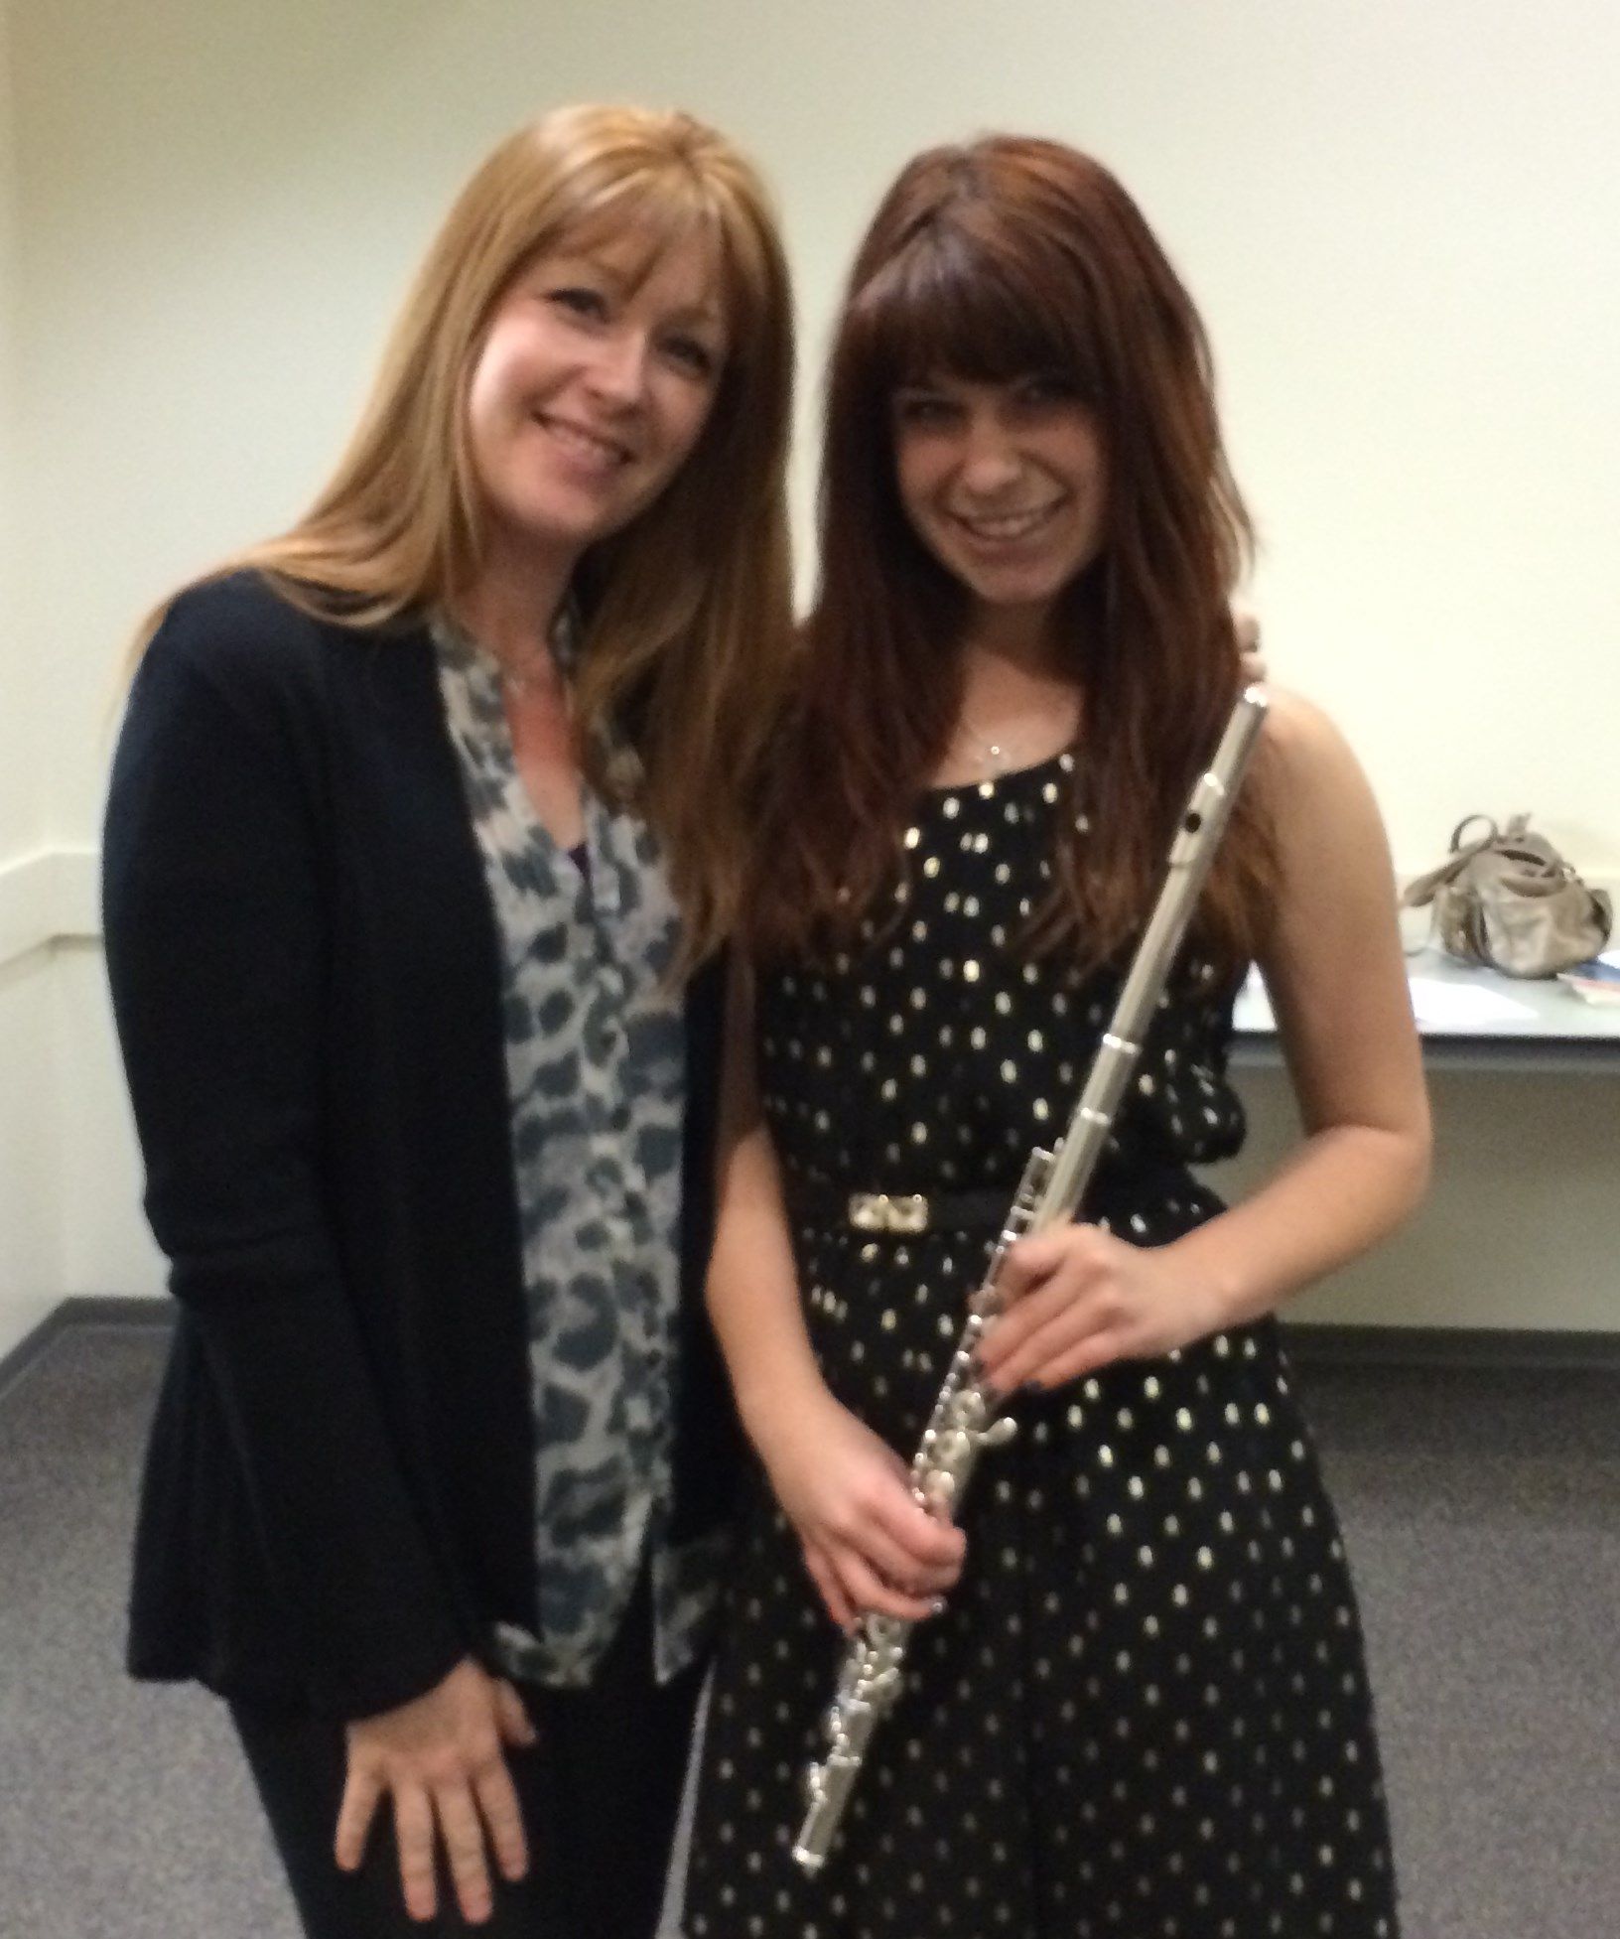

Welcome new student
Josie Ré
8th Grade, Shivela Middle School

Congratulations, to students who completed and passed Certificate of Merit evaluations:

Chloe Degaris, Level 1

Gaebriel Hefley, Level 2

Moriah Hefley, Level 2

Brittaney Johnson, Level 3

Natalie Smith, Level 3 Branch Honors

Anneliese Reinhofer, Level 6
Branch Honors

