
Kara Wuchner Flute Studio
www.karawuchner.com
(714) 227-5581

August 1st, 2014.
Upcoming Events and Dates to Remember:
August 30: Lesson make-up day

September 13: MTAC Musicales
Temecula Library

October 18: MTAC Halloween Musicales – come in costume!
Temecula Library

November 15: Sonata Festival
Temecula Library

November 18: Fall Studio Recital
Calvary Baptist Church

November 24-28: No Lessons Given
Happy Thanksgiving!

December 13: MTAC Holiday Musicales – an opportunity to perform your favorite holiday pieces!
Temecula Library

December 22-January 6: No Lessons Given
Merry Christmas!

♪Notable Student♪

Anneliese has been my student for several years now. I have enjoyed watching her grow and mature into a beautiful young lady and musician. I am very sad, and at the same time excited for her, as she moves on and pursues her dreams. She will be attending Humboldt State University and wants to someday be an Occupational Therapist.
Anneliese Reinhofer

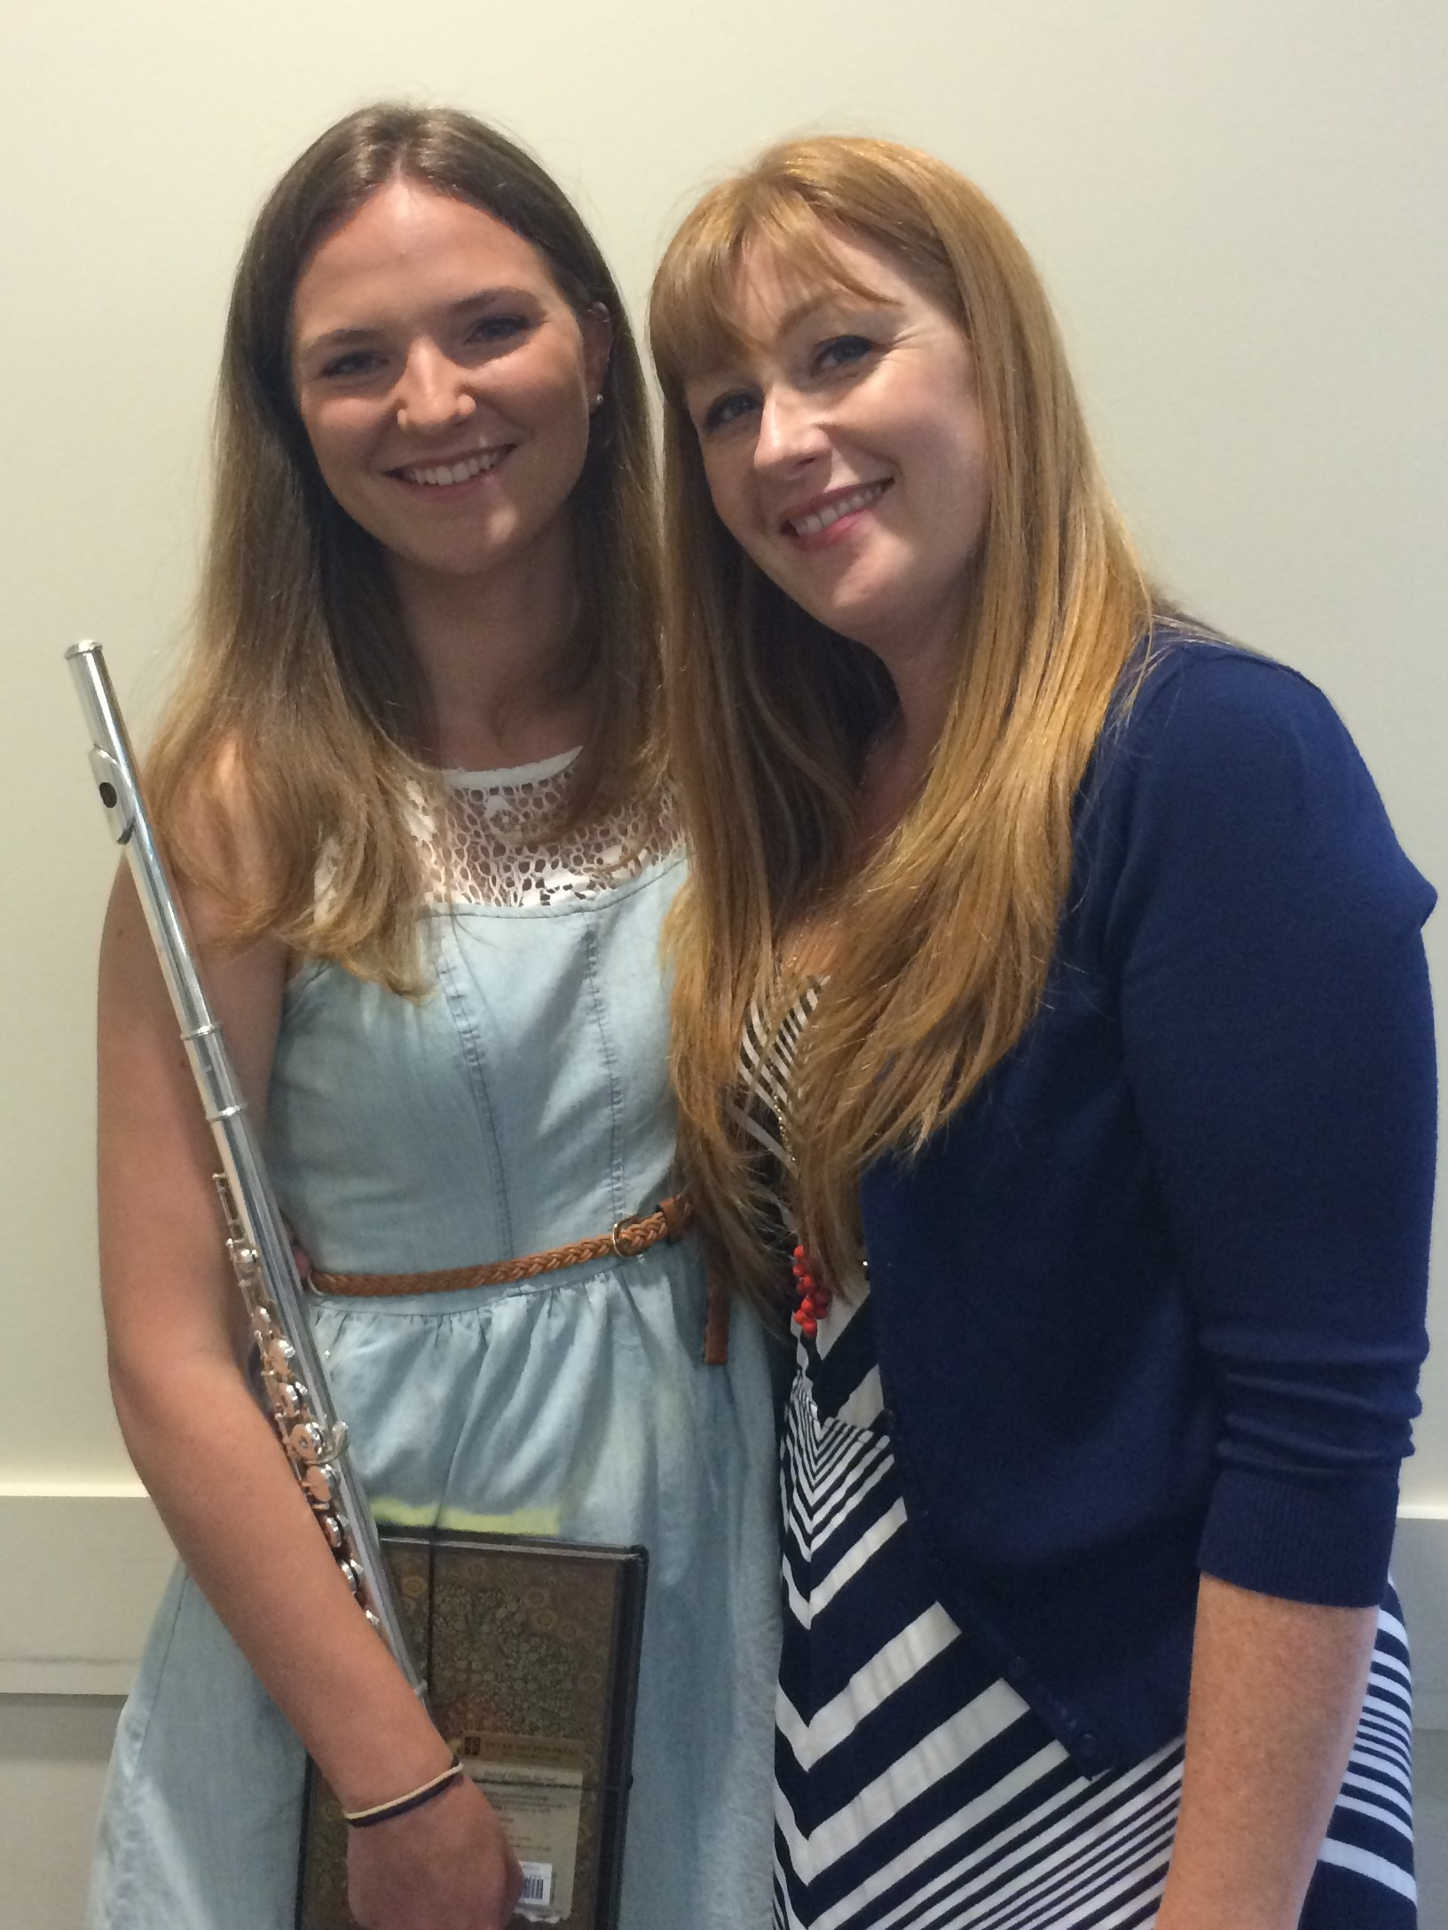

I can’t believe summer is nearly over! I hope everyone’s was enjoyable and at least a little relaxing. Because of summer schedules being irregular, several of you have a make-up lesson owed you. I will be having a lesson make-up day on August 30th at my home studio. Contact me to arrange a time.

There are several opportunities to perform coming up this fall. Let me know if you’d like to participate in any of the listed events. The library “musicales” are great opportunities to play for friends and family in a casual environment. The Sonata Festival is for students who are working on a Sonata. They will receive judge’s comments on their performance, receive a certificate, and have an opportunity to receive an award.

Capriccio Flute Choir will break until January

For those of you looking to be further challenged, there are a couple great youth orchestra programs in our area. Auditions for the 2014-2015 year are being held very soon!

Inland Valley Youth Symphony, Aug. 11th www.inlandvalleyyouthsymphony.org

Bravura Youth Symphony, Aug. 18th
www.bravurayouthorchestra.com

Please let me know ASAP if you need to adjust your lesson time. My school year hours are as follows:
Mondays and Thursdays 4-7 at Master Musician
Fridays 3:30-7 at my home studio
(Remember: please give me 24 hours notice of any absence and I will do my best to make it up. If less than 24 hours is given, you will be charged the full rate and a make-up is not guaranteed. A cancelation fee of $7.00 will be charged for any absence at Master Musician, regardless of the reason.)

